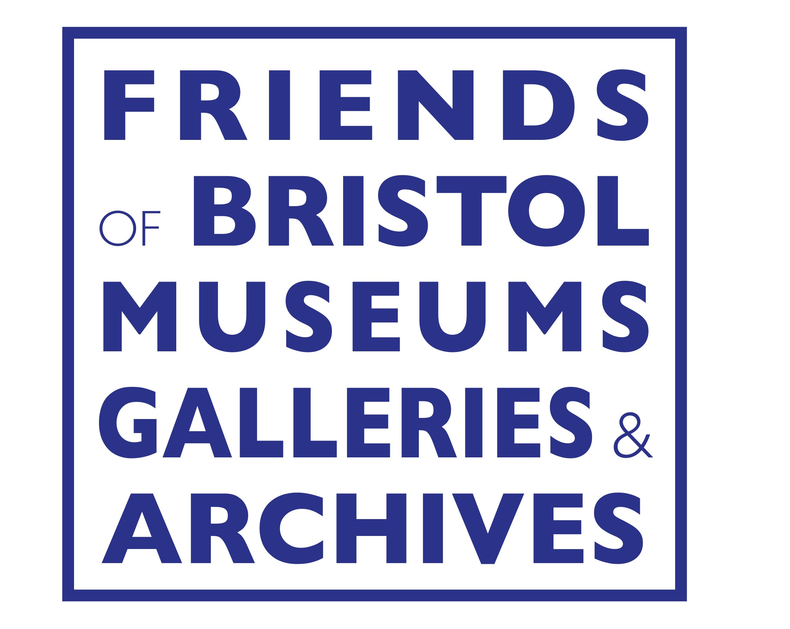
NOTICE OF
ANNUAL GENERAL
MEETING

All Friends are warmly invited to the Annual General Meeting, which will be held

at 2.30 pm
on Saturday 17 October 2026
at The Studio, M Shed, Prince’s Wharf, Bristol BS1 4RN

The AGM business will be kept to a minimum and will be followed by some interesting short presentations by museum staff on some of their current projects. We’ll conclude with tea and cake.

Do please come to celebrate our active and successful Friends organisation. This is your chance to give us feedback and suggestions for the future.

AGM AGENDA
1. Introduction and apologies for absence.
2. To approve the minutes of the AGM held on 25 October 2025.
3. To take any matters arising.
4. To receive the Annual Report.
5. To receive the Annual Accounts.
6. To elect nominees to the posts of Officers of the Association and to Executive Committee membership.
(See over for brief profiles of all known candidates.)
7. To appoint an Independent Examiner.
8. Any other business, properly that of an Annual General Meeting.

Election of Executive Committee officers and members
The current officers of the Executive Committee of the Friends of Bristol Museums, Galleries and Archives are: Sue Thurlow, Chair; Katherine Martin, Secretary; Steve Sparks, Treasurer; and Richard Avery, Membership Secretary. The remaining elected members of the committee are: Mary Bailey, Ray Barnett, Clive Burlton, Susan Hibberd, Carol Lear and Toby Pinn, leaving two vacancies. If you are interested in standing this year, please speak to the Chair or the Secretary.
KNOWN CANDIDATES STANDING FOR ELECTION

Richard Avery: Richard had a career spent mostly in the electricity supply industry and in education finance in Bristol. He is a founder member of FBMGA and has served as Secretary. He is now Membership Secretary and webmaster. Retirement in November 2019 has enabled him to spend more time looking after his vintage Bristol coach and bus.

Mary Bailey: Mary has had three separate careers: FCO (Austria and Argentina), 22 years in public relations at Harveys of Bristol and seven years at Children’s Hospice South West (fundraising). A founder member of FBMGA (then Bristol Magpies) in 1977, she has served as Secretary and Chairman. She now chairs the Events Group.

Ray Barnett: A Bristol graduate, Ray took early retirement from the position of Head of Collections & Archives for Bristol Culture at the end of 2022. He is still involved with the museum service assisting to curate the collections and support the environmental records centre through his specialism in entomology.

Clive Burlton: After a corporate and consultancy career, Clive became a volunteer at Bristol Archives in 2008 where he helped to digitise and catalogue films. He co-founded Bristol Books CIC in 2012 and has written five books and co-authored three others. He gives talks and film shows across Bristol and runs tours to the Western Front.

Susan Hibberd came to Bristol in 1962 as a student, married and stayed in the area. She taught German and French for many years in the state sector and also German for the OU. She joined the old “Friends” (with husband John) in 1997 and was closely involved, as he was, on the committee. Loves visiting galleries, classical concerts and travel (when possible).

Carol Lear: Carol taught Classics and regularly took students to Greece and Italy. Her interest in art and history was fostered in the museum which, as a Bristolian herself, she has visited and enjoyed all her life. She has been Chairman and Social Secretary of the Friends (of the Art Gallery) and is a Guide at Lifeskills.

Katherine Martin: Born in London, she came to Bristol as a student (of theology) and never left. She ran Hope Centre in Hotwells and was then business manager of Backwell School. She enjoys being on the committee because it gives an insight into how museums are run and is also involved in playing music and badminton.

Toby Pinn: Toby is a Chartered Arts & Antiques Surveyor and runs an independent RICS regulated art & antiques valuation business. He was a member of the FoBAG Committee from 2009 until the merger, having joined FoBAG in 2001. Toby’s interests extend across the full range of the museum service collections.

Steve Sparks: Is Emeritus Professor of Geology at the University of Bristol and has a wide range of science interests. He is best known as a volcanologist. He has a strong interest in public understanding of natural sciences and collaboration between arts and sciences. He was a Trustee of the Natural History Museum and of Clevedon Pier.

Sue Thurlow: With an art dealer for a father, studying physics at university, then becoming an accountant and later a skills coach, Sue’s interests are wide-ranging. She’s been our Chair since 2011, and a museum volunteer in many capacities for over 30 years. If you want to know more, ask her!

